
ОБЩЕСТВО С ОГРАНИЧЕННОЙ ОТВЕТСТВЕННОСТЬЮ
«ЛАЗЕРТАГ»

ПАСПОРТ

Смоленск


LIMITED
LIABILITY COMPANY
LASERTAG

SPECIFICATION

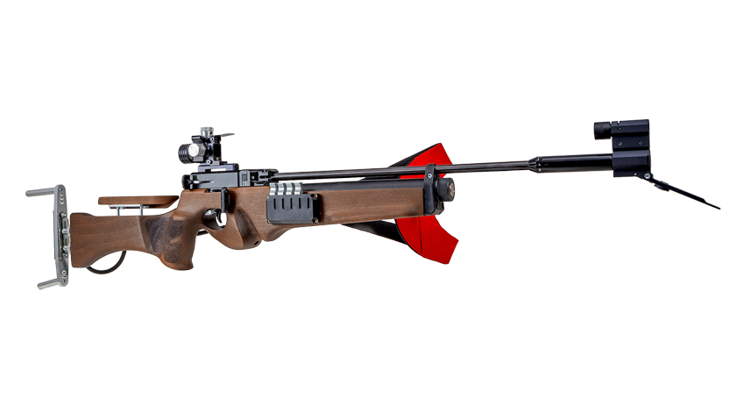

Game set

2.0 LASER BIATHLON TRAINER

Dear Customer!
Our company welcomes and thanks you for the decision to buy our products, and is confident that the purchased device will bring you a long-term pleasure. The warranty certificate establishes the guarantee of the product in the amount provided for by the Law on consumer protection of the Russian Federation.
This warranty certificate is valid for 12 months from the purchase date of the product, provided the guarantee terms are observed.

- Contact information
Official website:
www. laserwar.com

E-mail:
help@laserwar.com

Skype:
help@laserwar.com

_____________________
Stamp signature

2
11

Purchase Date: _______________
- The intent of the device
2.0 LASER BIATHLON TRAINER is a set of sports equipment, designed for biathlon athletes training.

- Technical Specifications
Weight (total) | 15 kg
Weight of supports | 2.6 kg
Weight of racks | 2.5 kg
Weight of the rifle | 3.4 kg
Weight of the target | 6.9 kg
Tagger battery type | Li +
Battery charger type | Mini-usb 5V
Off-line work time (tagger/target) | Up to 40 hrs/up to 10 hours.

Information on the repairs performed during the maintenance period (completed by the Service center performing the warranty repair works).

Date: __________________  Completed work: _____________________________________________________________________  Service center stamp | Date: __________________  Completed work: _____________________________________________________________________  Service center stamp
Date: __________________  Completed work: _____________________________________________________________________  Service center stamp | Date: __________________  Completed work: _____________________________________________________________________  Service center stamp
Date: __________________  Completed work: _____________________________________________________________________  Service center stamp | Date: __________________  Completed work: _____________________________________________________________________  Service center stamp

3
10
- Contents of delivery

№  Ser. No. | Name | Unit of Measure | Quantity
1. | Biathlon target | pc. | 1
2. | Racks | pc. | 2
3. | Supports | pc. | 2
4. | Biathlon tagger | pc. | 1
5. | Specification | pc. | 1

- Description and work
  - Device
The game set consists of six parts: Two height-adjustable racks, two supports, a target, a biathlon tagger.
2.0 LASER BIATHLON TRAINER is designed for sports and training activities.

  - Changing the performance characteristics
In configuration mode, you can change the following options: Voice settings, number of additional cartridges (replaceable magazines). To enter the settings mode, run the adjustment fire mode be pulling the bolt three times. A sound will announce you've entered the configuration mode. To change the configuration, you are editing, click the reload button again. Press the trigger to choose the required configuration.

Warranty Terms:

1. The guarantee is effective upon presentation of the present certificate, which indicates the purchase date of the equipment confirmed by the service center.
2. These guarantee obligations apply to products acquired only from the official LASERTAG representative or the official dealer.
3. The present guarantee is invalid if the product deficiencies have occurred in the following cases:
- failure to comply with Operating instructions;
- mechanical damage;
- penetration of extraneous items, liquids, etc.;
- animal activities;
- unauthorized access to the parts of the game set by non-authorized persons;
- use of the product for purposes for which it hasn't been made;
- Acts of elements (natural disaster, fire, accidents, etc.);
- the game set malfunction in case of faulty power network and/or poor care of the product.
4. If the warranty certificate is lost, no duplicate is issued.

4
9
  - Pre-starting procedure
A biathlon tagger is turned on with the help of the button located on the end of the shoulder stock. By default, the rifle has 5 rounds. Reload the rifle by pulling the bolt.

You can enter the adjustment fire mode. To do this, take the turned off rifle, pull the bolt, turn on the game set and press three times on the trigger. After that the sound will announce that the adjustment fire mode has been activated. This mode helps to configure sighting equipment. The remainder of the ammo is not controlled (it is infinite). You don't have to reload the rifle after each shot.

The target is activated with the help of an anti-vandal lock located at the back.
The player should shoot at the black targets, the sensors of which are slightly pushed inside to protect the device against sunlight. When the target is hit you'll hear a corresponding sound. The LED inside the target will light up white. The recommended distance to the target – 25 - 50 meters. Resetting to zero is quite easy: Use the "New Game" option from the remote control.

It is FORBIDDEN to use a biathlon tagger in laser tag games!

- 2.0 LASER BIATHLON Guarantee commitment
The manufacturer guarantees the reliability of the operation of an individual LASERWAR set if the consumer has complied with the conditions of use. The manufacturer undertakes to replace or repair an individual set of equipment free of charge, if the customer has complied with the rules for the device transportation, storage, operation and delivery of defective equipment to Smolensk City.
The warranty is 14 days for batteries, speakers, and IR modules.
PLEASE NOTE! In the case of improper operation of the accumulator (charging by an unrelated type of a charger), the warranty doesn't cover the battery!
You can see on our website a complete technical maintenance manual for laser tag equipment: www.cybertag.ru.

5
8
6
7
- Operating rules
1. Weather conditions. We strongly recommend that the equipment shouldn’t be used in the rain and at temperatures below -20°C. Avoid getting moisture inside the frame. If this happened, turn off the device, dry the equipment at room temperature for at least two hours.
Having used the device at low temperatures don't try to charge it immediately after the game. Wait for electronics to warm up.
2. Batteries.
The biathlon tagger has lithium batteries. To recharge the device use only a mini-USB 5V device.
Connect the charger to the device, and only then to the network.
You can control the recharge process with the help of a special indicator. If the battery is low, the LED is red. When the recharge process is complete, the color will be changed to green.
Please note! The game set must be recharged immediately after you have played with it under constant supervision at temperature no less than 0°С and no longer than for 2 hours.

3. Storage.
It is necessary to store the equipment in a well-ventilated space at temperature from + 18°C to + 30°C and relative humidity of 45-65%.
Store equipment only in charged state (ideally under nominal voltage conditions).

